Table of contents
Computational Methods
Results
Cα RMSD
Heavy Atom RMSF
Core Distances
Active Site Interaction Distances
Probability Density of Active Site Interactions
TUPA
Principal Component Analysis
Supplementary Information
Parameters obtained from MCPB.py
Equations for methods used
Per Replicate Time Series Distance Plots

Computational Methods
The initial structures for the MD simulations were obtained using the AI-based protein structure prediction algorithm, AlphaFold (https://doi.org/10.1038/s41586-021-03819-2, https://doi.org/10.1038/s41586-024-07487-w). This structure was based on the human tyrosinase-like protein (TYRP1A) and was used as the reference for this system. The first-ranked structure was selected for both the dark (WT) and the white (A160D) systems as the starting structures. The terminal residues had low confidence, based on the pLDDT (predicted local-distance difference test) scores. When we refer to the reference crystal structure for the AlphaFold system (TYRP1) (https://doi.org/10.1002/anie.201704616), we notice that they have resolved the structure from residue 25. This is the same for another TYRP1 crystal resolved more recently (2024) (https://doi.org/10.1002/cbic.202400235), and similar trends are noticed with other resolved tyrosinases from various organisms (https://doi.org/10.3390/biom13091360, https://doi.org/10.1002/anie.201901332, https://doi.org/10.1002/anie.201506994 ). The N-terminal domain of most tyrosinases and tyrosinase-like protein consists of a signaling peptide, which is difficult to resolve due to its flexible nature. As for the C-terminus, that region mainly consists of a transmembrane α helix (that gets embedded into the membrane) and a small flexible regulatory domain; that gets cleaved for the enzyme to be active. Since the helix is more often embedded in the membrane and the regulatory domain is cleaved/is too flexible, these regions do not get properly resolved in crystal structure. Based on this, as well as the fact that we are not studying the tyrosinase embedded in membrane, our systems were truncated at a higher confidence region in both the N and C termini. For the C-terminus, the system was truncated at residue Glu 462, and the N-terminus was truncated at residue Gln 26. Since the AlphaFold structures did not have the oxy-tyrosinase core, a separate PDB with the oxy-tyrosinase core (1WX4) (https://doi.org/10.1074/jbc.M509785200) was used as a reference for the positioning of the Cu₂O₂ core. 1WX4 was overlaid with the truncated WT and A160D systems, and the oxy-tyrosinase core was extracted and put into the heron systems.
Since the starting structures are obtained from AlphaFold, they do not contain any hydrogen atoms in them. Therefore, to obtain proper protonation states for the residues present in the system, the H++ server (https://doi.org/10.1093/nar/gks375, https://doi.org/10.1002/prot.20922) was utilized. A pH of 7.5 was used, which is the physiological pH of herons.
Since AMBER does not contain parameters for the oxy-tyrosinase core, it was parameterized using AMBER's MCPB.py (Metal Center Parameter Builder) algorithm (https://pubs.acs.org/doi/full/10.1021/acs.jcim.5b00674). MCPB.py identifies the metal site, defines bonded and nonbonded interactions with nearby ligands, and then combines QM calculations (for bond/angle parameters and charges) with classical force field information. For our system, the Gaussian16 (https://gaussian.com/citation/) QM package was used for the optimization and partial charge calculation. The optimization and force constant calculation was done using the B3LYP/6-31G* level of theory and the Mers Kollman RESP (https://doi.org/10.1021/j100142a004 ) charge calculation is done to obtain partial charges using the same level of theory. The parameters obtained from MCPB.py are consistent with previously reported data (https://doi.org/10.1007/s00775-009-0577-6) and are provided in the SI.
Once the core was parameterized, it was included in the system using the LeAP module of AMBER. The protein was treated with the ff19SB (https://pubs.acs.org/doi/full/10.1021/acs.jctc.9b00591), and the water and ions were treated with the OPC model(https://pubs.acs.org/doi/10.1021/jz501780a). LeAP also adds hydrogens to the system based on the protonation states determined earlier. The system was then put in a cubic water box with a 10 Å cutoff from the edge of the protein, and the system was neutralized with Na+ ions. For the wild type, the box size was 80.20 Å x 90.74 Å x 83.34 Å, with 136099 total atoms. For the mutant, the box size was 80.20 Å x 90.74 Å x 83.33 Å, with 136105 total atoms.
The MD simulations for both systems were carried out using AMBER24's pmemd.mpi (for minimization, heating, and relaxation) and pmemd.cuda (for equilibration and production). (https://doi.org/10.1021/ct400314y, https://doi.org/10.1002/jcc.20829) The system was minimized for a total of 10,000 cycles, with 5,000 cycles using the steepest descent method and the remaining 5,000 cycles using the conjugate gradient approach. The system was then gradually heated to 41°C/314K (physiological temperature of heron) using Langevin dynamics (https://doi.org/10.1063/1.481811) with a collision frequency of 2 ps⁻¹. During heating, all heavy atoms were restrained with a force constant of 100 kcal mol⁻¹ Å⁻². After the heating step, these restraints were gradually reduced until the system was fully unrestrained. The equilibration step continued without restraint until stability was achieved, followed by a 1.5 μs production run using the NPT ensemble. Molecular dynamics simulations were propagated using a 2 fs integration time step with bonds involving hydrogen constrained using the SHAKE algorithm (https://doi.org/10.1016/0021-9991(77)90098-5). Coordinates were written to the trajectory every 5,000 MD steps, corresponding to 10 ps between saved frames. Long-range Coulomb interactions were handled with the smooth particle mesh Ewald (PME) (https://pubs.acs.org/doi/10.1021/ct400314y) and long-range van der Waals interactions were approximated using the default isotropic correction (in AMBER) ( https://doi.org/10.1002/jcc.540150702), with a 10 Å cutoff for non-bonded interactions. Three replicate trajectories of 1.5 μs were carried out for each system. Unless otherwise noted, simulation analyses were done on the last 1.3 μs of each replicate, excluding the first 200 ns for equilibration. All the analyses were done on the full simulations, not skipping any frames. This is reasonable for computing mean values and distributions, as per ergodic hypothesis, since time-averaging over a sufficiently long trajectory should converge to the true ensemble average regardless of frame-to-frame correlation. Moreover, certain aspects of the simulations tend to adopt different states, and it is inconsistent over a replicate as well as between replicates. Hence, skipping frames might lead to over or underestimation of certain states. Therefore, considering every frame gives us a better representation of the overall characteristics of the simulations.
CPPTRAJ (https://pubs.acs.org/doi/10.1021/ct400341p) was utilized to carry out Root Mean Square Deviation (RMSD) and Root Mean Square Fluctuations (RMSF) of the systems. The RMSD was calculated for the Cα atoms per replicate of each system with the starting structure as the reference. The RMSF was calculated based on all heavy atoms with the starting structure as the reference.
Probability densities were calculated using the SciPy (v. 1.13.1) module (10.1038/s41592-019-0686-2, https://pypi.org/project/scipy/1.13.1/) of python with the kernel density estimation (KDE) algorithm (equation in SI). For each trajectory, KDE was performed on the collected distance values using Gaussian kernels. Local maxima of the resulting probability density were identified ranked by density magnitude, yielding the different conformational states. The relative population of each identified state was estimated by nearest-peak assignment: every individual distance observation was assigned to whichever KDE peak it was closest to in distance space, and the population of a given state was calculated as the fraction of all observations assigned to it.
Hydrogen bond analysis was done using the CPPTRAJ suite of AMBER. CPPTRAJ identifies and keeps track of hydrogen bonds over the course of a trajectory, based on geometric criteria, with a default distance of 3 Å and an angle of 135° were selected as the cutoffs. All the plots are made using Matplotlib(https://doi.org/10.1109/MCSE.2007.55) and the structural figures are made with PyMOL(PyMOL:The PyMOL Molecular Graphics System, Version 3.0 Schrödinger, LLC) (Citation obtained from: https://www.pymol.org/support.html).

Results:

C-alpha RMSD (Equation in SI):
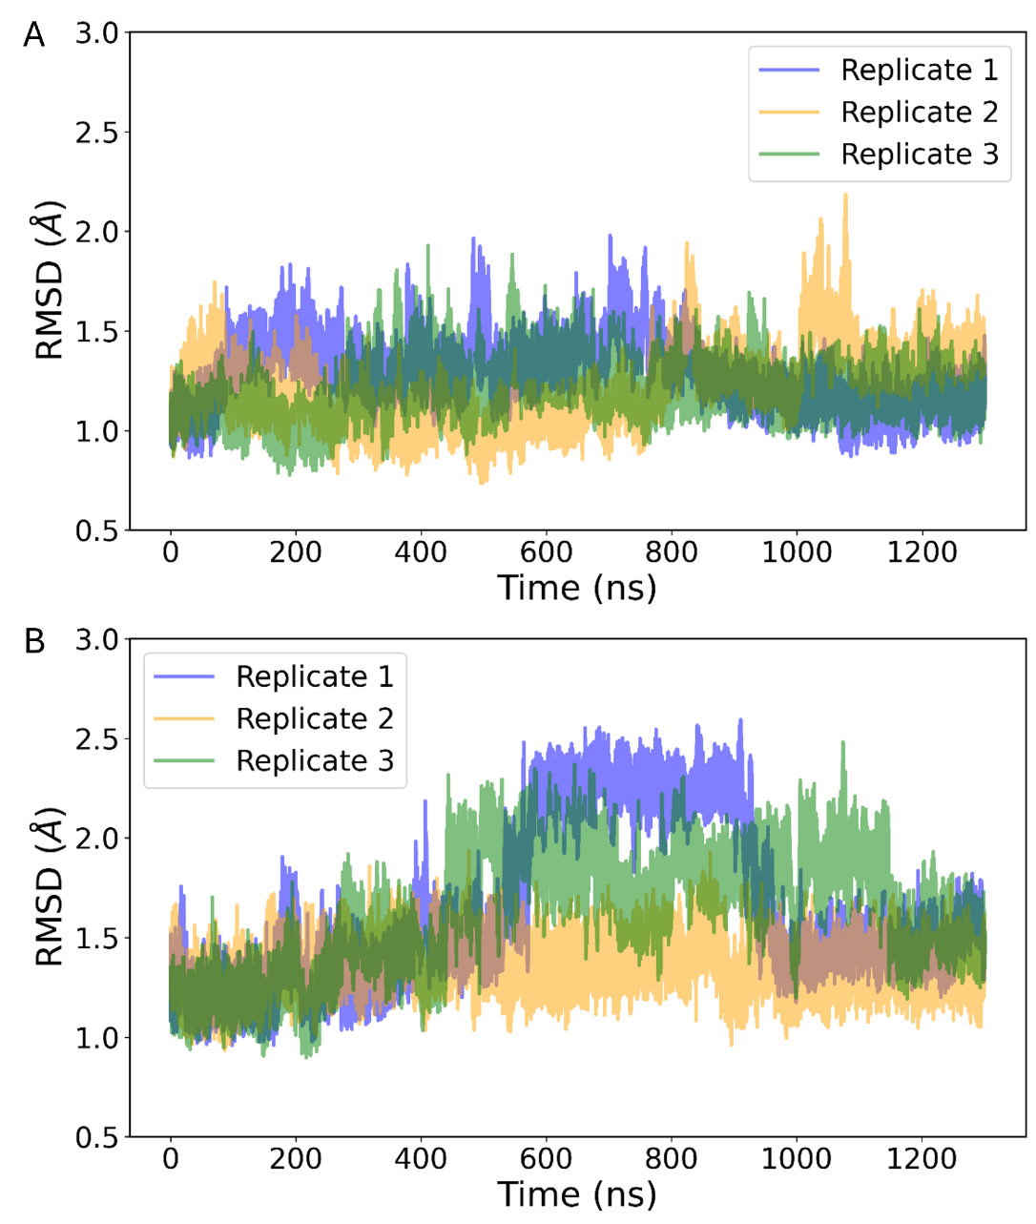
Figure 1. RMSD of Cα atoms of the protein residues for the three replicates of the dark (A) and the white (B) simulations over 1300 ns per replicate. The dark system shows more stable RMSDs, indicating a more stable structure during the simulations. The white systems show more deviation, indicating higher flexibility.

Heavy atom RMSF (Equation in SI):
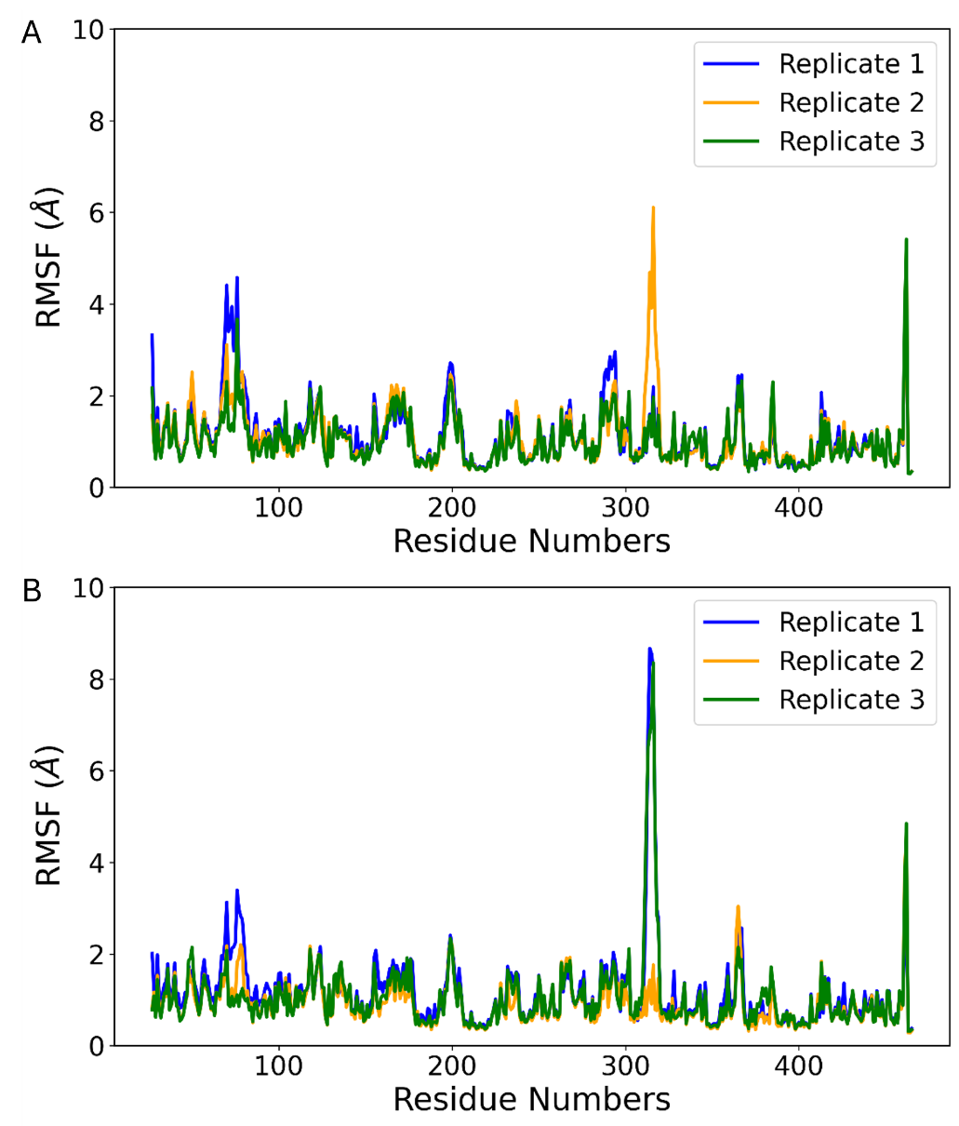
Figure 2. Per residue RMSF of heavy atoms for the three replicates of the dark (A) and white (B) simulation over 1300 ns per replicate. A distinct peak showing higher fluctuations is seen after residue 300 (a solvent accessible loop) in both systems (Replicate 2 in Dark and Replicate 1 and 3 in White). Terminal residues also show higher fluctuations, which are expected.

Core Distances (Concatenated data from each replicate) (Equation in SI)
Table 1: Mean, standard deviation, minimum and maximum values (in Å) for distances of the parameterized Tyrosinase core averaged over the concatenated values of three replicates for dark and white systems respectively. The values show stable core interactions with average distances aligning with literature, as well as low standard deviations throughout.
Distance | System | Mean (Å) | St. Dev. (Å) | Min. (Å) | Max. (Ã)
H188-CuA | Dark | 2.04 | 0.07 | 1.74 | 2.35
H188-CuA | White | 2.05 | 0.08 | 1.74 | 2.35
H210-CuA | Dark | 1.98 | 0.06 | 1.67 | 2.27
H210-CuA | White | 1.98 | 0.06 | 1.67 | 2.27
H219-CuA | Dark | 2.19 | 0.09 | 1.81 | 2.60
H219-CuA | White | 2.19 | 0.09 | 1.78 | 2.57
H371-CuB | Dark | 1.96 | 0.07 | 1.65 | 2.29
H371-CuB | White | 1.96 | 0.07 | 1.57 | 2.30
H375-CuB | Dark | 1.97 | 0.06 | 1.69 | 2.26
H375-CuB | White | 1.97 | 0.06 | 1.69 | 2.26
H398-CuB | Dark | 2.05 | 0.09 | 1.66 | 2.47
H398-CuB | White | 2.05 | 0.08 | 1.61 | 2.48
O1-O2 Per | Dark | 1.43 | 0.03 | 1.31 | 1.55
O1-O2 Per | White | 1.43 | 0.03 | 1.30 | 1.56
CuA-CuB | Dark | 3.56 | 0.08 | 3.19 | 3.91
CuA-CuB | White | 3.57 | 0.08 | 3.19 | 3.90
CuA-O1 | Dark | 1.91 | 0.06 | 1.67 | 2.17
CuA-O1 | White | 1.91 | 0.06 | 1.63 | 2.17
CuA-O2 | Dark | 1.96 | 0.07 | 1.67 | 2.27
CuA-O2 | White | 1.97 | 0.07 | 1.65 | 2.27
CuB-O1 | Dark | 2.00 | 0.07 | 1.67 | 2.33
CuB-O1 | White | 2.00 | 0.07 | 1.65 | 2.31
CuB-O2 | Dark | 1.88 | 0.06 | 1.62 | 2.14
CuB-O2 | White | 1.89 | 0.06 | 1.61 | 2.13

Active site interactions distances (Concatenated data from each replicate)
Table 2: Mean, standard deviation, minimum and maximum values for active site interaction distances averaged over the concatenated values of three replicates for both dark and white systems respectively
Distance | System | Mean (Å) | St. Dev. (Å) | Min. (Å) | Max. (Ã)
V385 COM-CuA | Dark | 6.86 | 1.49 | 4.65 | 11.65
V385 COM-CuA | White | 6.58 | 0.78 | 4.93 | 10.97
Q386@O-H188@HNδ | Dark | 2.71 | 0.78 | 1.55 | 5.62
Q386@O-H188@HNδ | White | 2.18 | 0.63 | 1.53 | 5.89

Probability Density Analysis of Active Site Interactions
(Average and standard deviations obtained using respective values for each replicate)
(Equation in SI)
Gln386-H188 Distance:
Dark
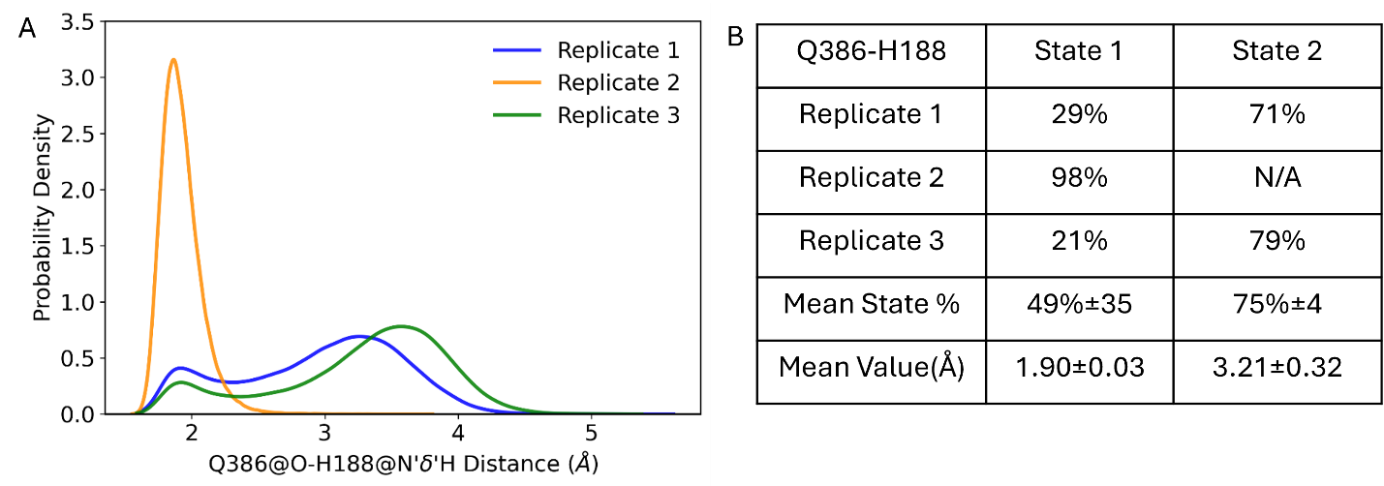
Figure 3. (A) Probability density of the distance between the hydrogen connected to Nδ of H188 to backbone O of Q386 in the three replicates of the dark simulations. (B) Per replicate state populations for the two distinct states observed. State 1 is the first peak (prevalent H-bond) and State 2 is the second peak. N/A indicates that there was no significance presence of that state in that replicate. The mean value represents the average peak value for each state across the three replicates.
White
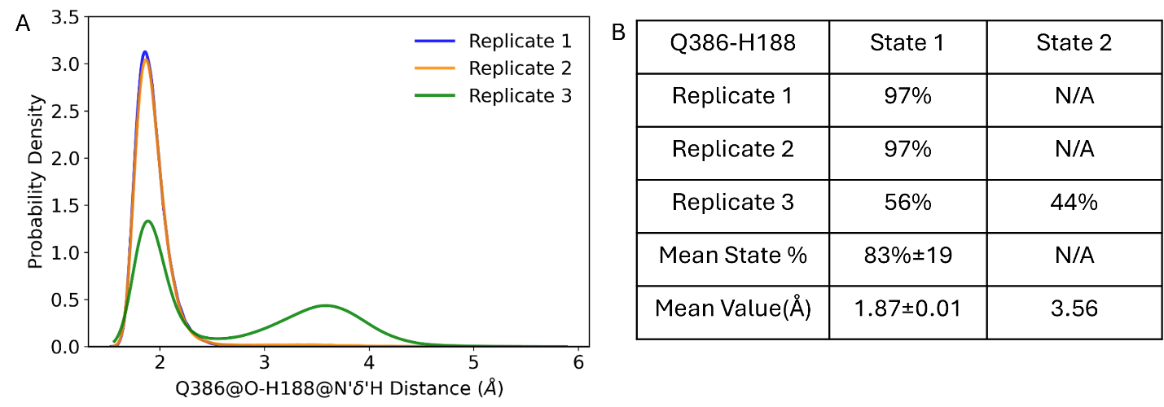
Figure 4. (A) Probability density of the distance between the hydrogen connected to Nδ of H188 to backbone O of Q386 in the three replicates of the white simulations. (B) Per replicate state populations for the two distinct states observed. State 1 is the first peak (prevalent H-bond) and State 2 is the second peak. N/A indicates that there was no significance presence of that state in that replicate. The mean value represents the average peak value for each state across the three replicates.
V385-CuA Distances:
Dark
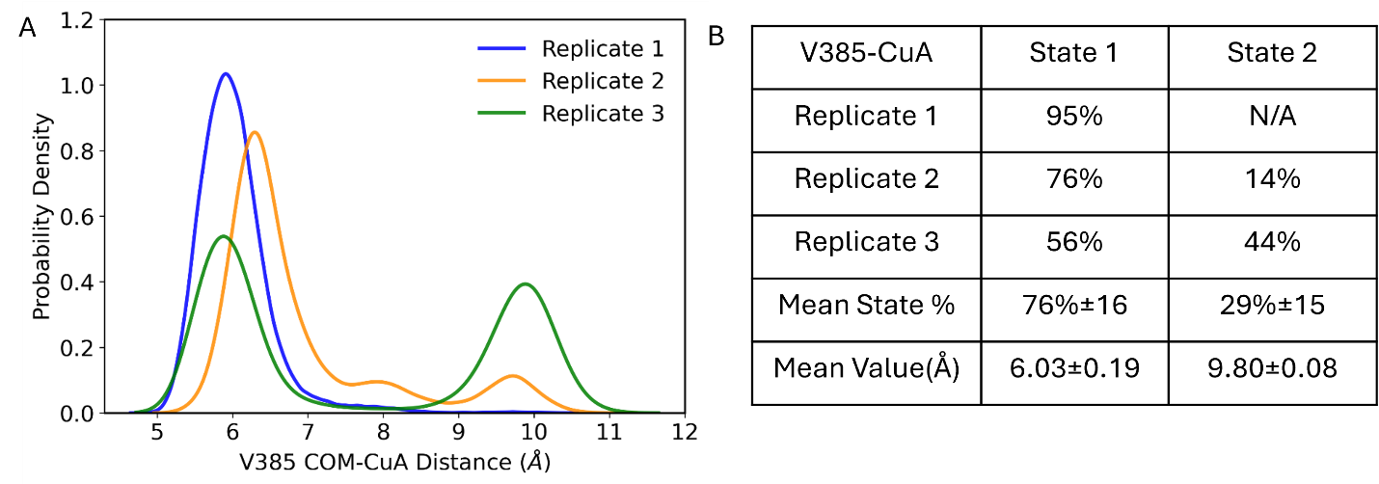
Figure 5. (A) Probability density of the distance between the center of mass of V385 to Copper A in the three replicates of the dark simulations. (B) Per replicate state populations for the two distinct states observed. State 1 is the first peak (closed conformation of V385) and State 2 is the second peak (open conformation of V385). N/A indicates that there was no significance presence of that state in that replicate. The mean value represents the average peak value for each state across the three replicates.
White
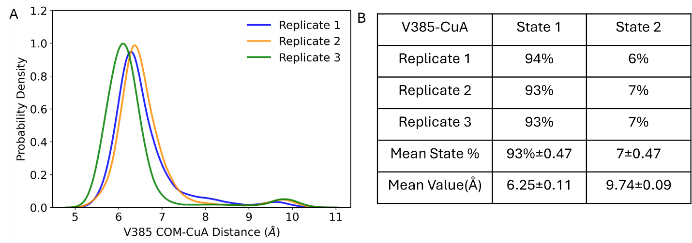
Figure 6. (A) Probability density of the distance between the center of mass of V385 to Copper A in the three replicates of the white simulations. (B) Per replicate state populations for the two distinct states observed. State 1 is the first peak (closed conformation of V385) and State 2 is the second peak (open conformation of V385). N/A indicates that there was no significance presence of that state in that replicate. The mean value represents the average peak value for each state across the three replicates.

Combined trajectory probability densities for active site interactions
(Obtained using concatenating data from all three replicates for each system)
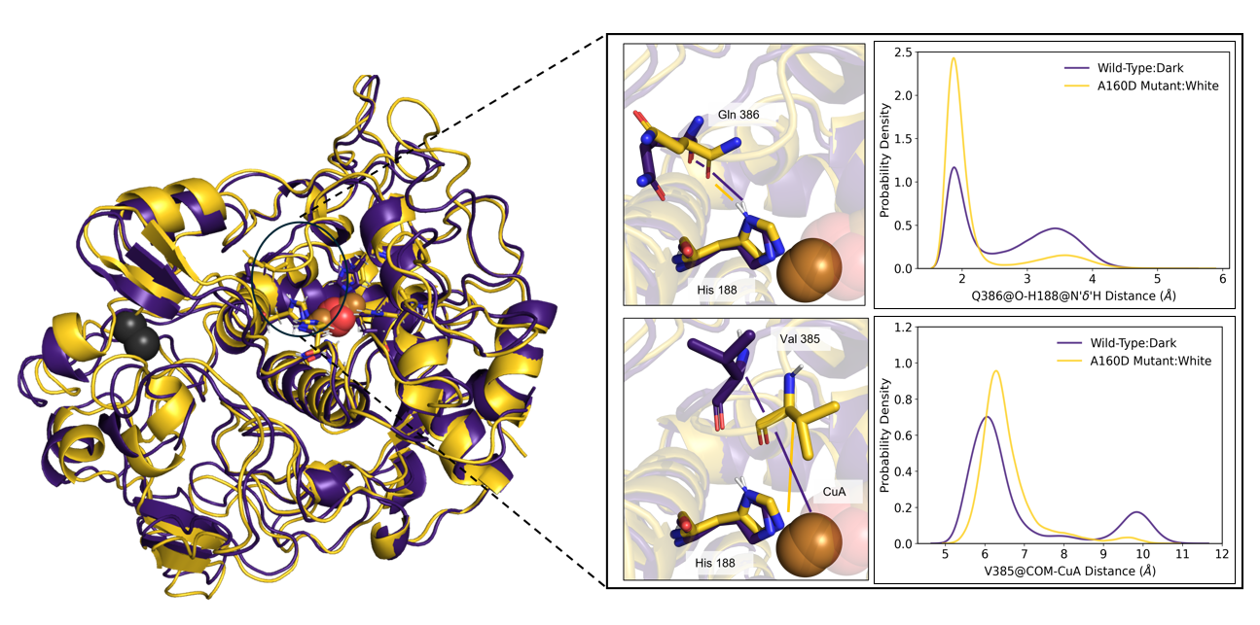
Figure 7. Probability densities for the concatenated data for the combined trajectories for the dark (violet) and the white (gold) simulations for the distance between the hydrogen connected to Nδ of H188 to backbone O of Q386 (top) and the distance between the center of mass of V385 to Copper A (bottom). The white system shows a much stronger hydrogen bonding interaction between the backbone of Q386 and the ring of H188. The white system also has a more prevalent closed conformation than dark for V385, which has previously been linked to higher activity (https://doi.org/10.1016/j.bbapap.2012.12.021). The peak values with their probability densities are as follows: Dark Q386-H188: 1.88Å (1.16), 3.43Å (0.46); White Q386-H188: 1.87Å (2.43), 3.59Å (0.15); Dark V385-CuA: 6.29 Å (0.96), 9.63 Å (0.033); White V385-CuA: 6.29 Å (0.96), 9.63 Å (0.033)

TUPA:
TUPÃ (v. 1.6.0) (https://doi.org/10.1002/jcc.26873) was used to calculate the electric field on the center of the peroxide bond in the system. It is a python-based algorithm that uses point-charge-based approximation to compute local electric fields generated by the environment at a specific location (probe) in the system (Equation in SI). It treats the atoms surrounding the probe as fixed point charges and then calculates the electric field at each frame of the trajectory by using Coulomb interactions. Then, it averages the values over the whole trajectory. TUPÃ can be very useful to see specific residues that contribute differently to the electric field at the point of interest in systems that are being compared.
We calculated TUPÃ on every 10th frame of the combined trajectories for the three replicates for each of the dark and white system. The probe was selected to be the bond between the peroxide oxygens. Once the data was obtained, we calculated the difference (A160D - WT) for the electric field contribution for all the residues in the system and placed a threshold at |0.2 MV/cm| for it to be significant.
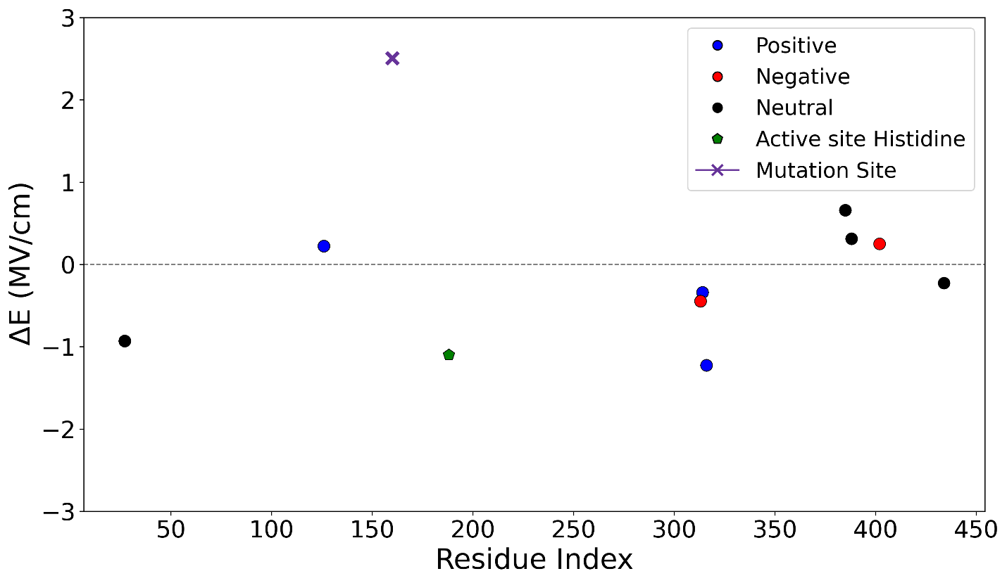
Figure 8. Difference in electric field (White-Dark) averaged over three replicates of the white and dark systems projected in the middle of the peroxide bond. Positive values indicate higher electric field contribution by that residue in the white (A160D) system and negative values indicate higher electric field contribution by that residue in the dark (wild type).
Table 3: Residues that show significantly higher (>|0.2| MV/cm) E to the middle of the peroxide bond.
Higher contribution to E in Dark | Higher contribution to E in Greater in White
Q27 | R126
H188 | A/D160
D313 | V385
K314 | S388
R316 | D402
M434

From the TUPA results, the mutation site shows a significantly greater contribution to the electric field in the mutant system compared with the WT system. This is consistent with the A to D mutation, which replaces a neutral alanine residue with a negatively charged aspartate and therefore substantially alters the local electrostatic environment around the active site.
V385 also makes a greater contribution to the electric field in the mutant/white system compared with the WT/dark system. One possible explanation is the difference in conformational sampling observed between the two systems. In the white simulations, the protein predominantly samples a more “closed” conformation, which may place V385 in closer proximity to the peroxide than in the dark simulations, where the protein samples the “open” conformation more frequently. The closer proximity of V385 to peroxide could therefore result in a larger electric-field contribution.
Several residues, including D313, K314, and R316, show greater electric-field contributions in the dark system. These residues are located on a loop that was observed to be more flexible in the white simulations and comparatively less flexible in the dark simulations. In the white system, the loop more frequently adopts a “flipped-out” conformation, which may place these residues farther from the peroxide. In contrast, the loop remains closer to the active-site region in the dark simulations, potentially allowing D313, K314, and R316 to make larger contributions to the electric field at the peroxide.
Q27 also shows a greater contribution in the dark system. In the white simulations, Q27 is frequently hydrogen bonded to D160, which may restrict its conformational freedom. The absence or reduced occupancy of this hydrogen bond in the dark system may allow Q27 to sample a wider range of conformations, including orientations that place it more favorably with respect to the peroxide and consequently increase its electric-field contribution.
The active-site histidine H188 contributes more strongly to the electric field in the dark system. In the white simulations, the HNE atom of H188 forms a hydrogen bond with the backbone oxygen of Q386. The absence or reduced occupancy of this interaction in the dark system may allow H188 to adopt a broader range of orientations. Some of these conformations may place the charged/polar groups of H188 in a more favorable orientation relative to the peroxide, resulting in a larger electric-field contribution.

Principal Component Analysis:
Principal Component Analysis (PCA) was done on the Cα atoms of the combined white and dark simulations using the sklearn (v. 1.7.2) (https://doi.org/10.48550/arXiv.1201.0490) module of Python between residues 30 and 459, to mitigate the effects of the higher flexibility of the terminal regions, on all of the frames. The principal components to be analyzed were determined using a scree plot shown in Figure 9. In our case, the cumulative variance for the first three PCs was around 37%, with a cumulative variance of around 75% where the plot flattens. This data is in agreement with recent studies (https://doi.org/10.1002/pro.70209, https://doi.org/10.1098/rsta.2015.0202, https://doi.org/10.1016/j.jgeb.2024.100444, https://doi.org/10.3390/ph17070880, https://doi.org/10.3389/fphar.2024.1494953)and the cumulative variance of the PCs is justified by the fact that this system is large (436 residues) and hence samples more space. Based on this as well as previously obtained data, we considered the cumulative variance of the system to be sufficient.
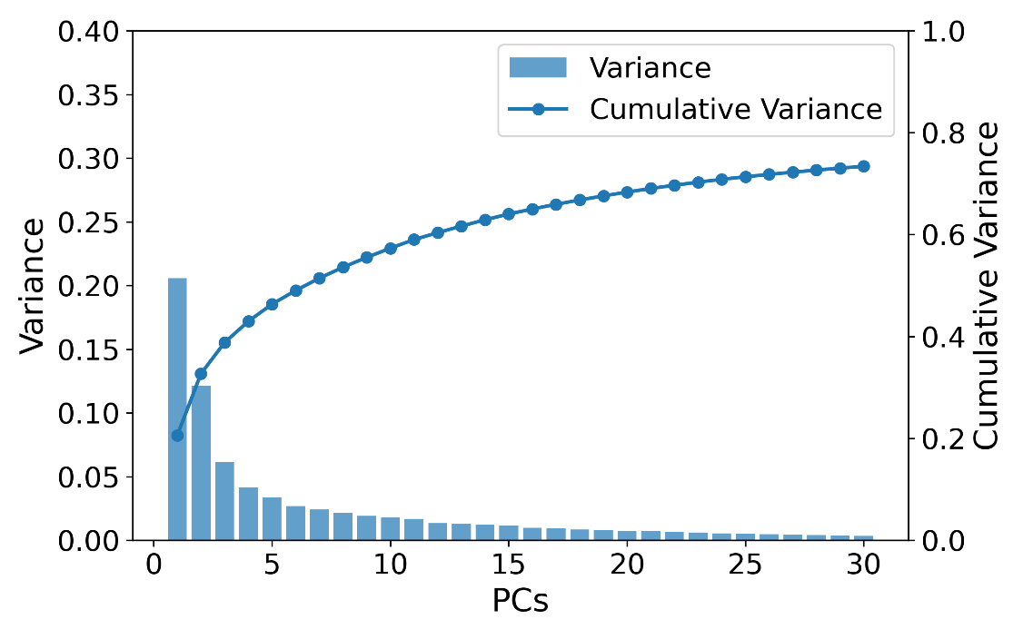
Figure 9. Variance per principal component and cumulative variance of the PCs calculated from combined white and dark simulations. Variance shows PC1 has the most contribution to the dynamics followed by PC2.
Per replicate PCA data for dark:
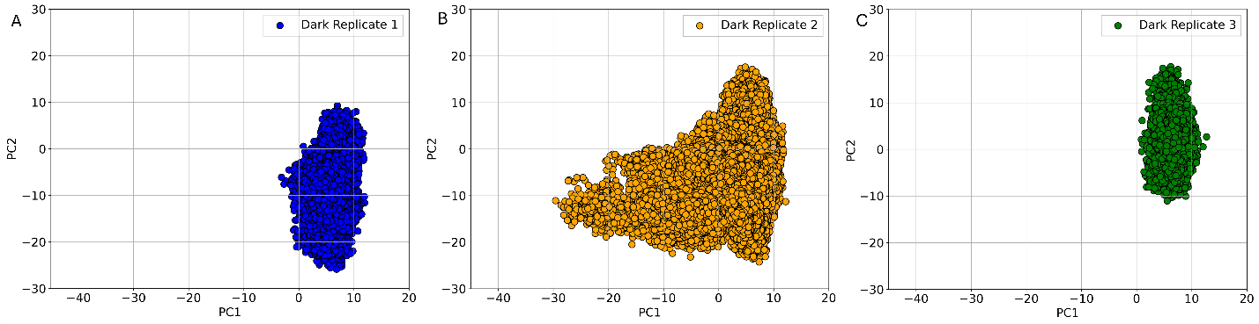
Figure 10. PCA plots for Cα atoms for the three replicates of the dark simulations. PC1 represents the movement of loop consisting of residues 310-320 (loop A) and PC2 represents the movement of the loop consisting of residues 166-177(loop B) (close proximity to the mutations site 160). As is seen here, the dark simulations are spread more on the PC2 than PC1 (all three replicates), showing the movement of loop B to be the major contributor. Replicate 2 does have a wide spread on PC1, which is expected as previously observed in RMSF where the fluctuations of loop A are higher in replicate 2 of dark.
Per replicate PCA data for white:
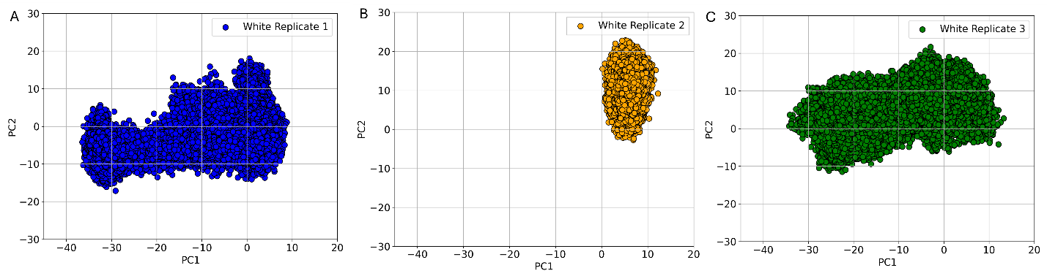
Figure 11. PCA plots for Cα atoms for the three replicates of the white simulations projected on the PCs of the dark simulations. PC1 represents the movement of loop consisting of residues 310-320 (loop A) and PC2 represents the movement of the loop consisting of residues 166-177(loop B) (close proximity to the mutations site 160). As is seen here, replicates 1 and 3 show a wide spread on PC1, indicating loop A movement to be the primary contributor to its dynamics.

Per residue contribution to PCA:
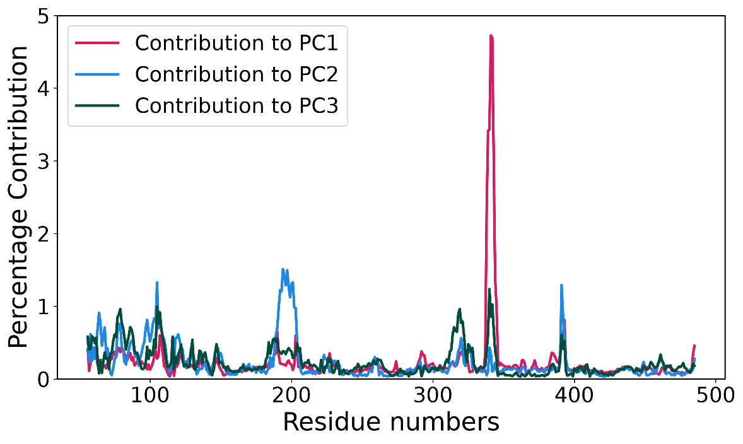
Figure 12. Per residue contribution to the combined PCA of dark and white systems. As expected, we see that PC1 loop A mostly contributes to the motion of PC1 whereas loop B contributes to the motion in PC2.

Supplementary Information

Parameters obtained from MCPB.py
Table S1. Partial charges (in elementary charge units, e) for all the atoms in the coordinating histidine residues to the oxy-tyrosinase core obtained using MCPB.py using the Mers Kollman RESP charge calculation.
Atom | H188 | H210 | H219 | H371 | H375 | H398
N | -0.4157 | -0.4157 | -0.4157 | -0.4157 | -0.4157 | -0.4157
HN | 0.3001 | 0.3478 | 0.3000 | 0.3243 | 0.3773 | 0.2823
Cα | 0.0188 | 0.0188 | 0.0188 | 0.0188 | 0.0188 | 0.0188
Hα | 0.0747 | 0.0720 | 0.1024 | 0.1473 | 0.0773 | 0.1299
Cβ | 0.2049 | 0.0899 | -0.0047 | -0.2581 | -0.1804 | -0.2566
Hβ2 | -0.0247 | 0.0405 | 0.0530 | 0.1042 | 0.0614 | 0.1355
Hβ3 | -0.0247 | 0.0405 | 0.0530 | 0.1042 | 0.0614 | 0.1355
Cγ | 0.0497 | -0.2070 | 0.0487 | 0.1502 | 0.0931 | 0.0802
Nδ1 | -0.0909 | -0.0136 | -0.1737 | -0.2853 | -0.1524 | -0.2419
Hδ1 | 0.3072 | 0.2723 | 0.2974 | 0.3493 | 0.3151 | 0.3357
Cϵ1 | -0.0730 | -0.0773 | -0.0529 | 0.0947 | -0.0388 | -0.0675
Hϵ1 | 0.1692 | 0.1679 | 0.1574 | 0.1529 | 0.1620 | 0.1813
Nϵ2 | -0.2139 | -0.1947 | -0.1919 | -0.2134 | -0.1923 | -0.1983
Cδ2 | -0.2381 | -0.0287 | -0.2002 | -0.0925 | -0.0862 | -0.0765
Hδ2 | 0.1885 | 0.1389 | 0.1687 | 0.1620 | 0.1359 | 0.1232
C | 0.5973 | 0.5973 | 0.5973 | 0.5973 | 0.5973 | 0.5973
O | -0.5679 | -0.5679 | -0.5679 | -0.5679 | -0.5679 | -0.5679

Table S2. Optimized distances (in Å) between coordinating histidine residues and the two copper ions of the oxy-tyrosinase core obtained with MCPB.py.
H188-CuA | H210-CuA | H219-CuA | H371-CuB | H375-CuB | H398-CuB
2.17 | 1.96 | 1.11 | 1.91 | 2.11 | 2.12

Table S3. Partial charges (in elementary charge units, e) obtained for the oxy-tyrosinase core using MCPB.py using the Mers Kollman RESP charge calculation.
Atom | Charge
O1 | -0.3346
O2 | -0.3295
CuA | 0.5039
CuB | 0.5053

Table S4. Optimized distances (in Å) between the atoms in the oxy-tyrosinase core obtained with MCPB.py.
CuA-O1 | CuA-O2 | CuB-O1 | CuB-O2 | O1-O2
1.97 | 1.92 | 1.96 | 1.88 | 1.48

Equations for methods used

CPPTRAJ RMSD Calculation:
RMSD measures the structural deviation between a reference frame and each trajectory frame, after optimal alignment by rotational or translational motion. The RMSD is calculated using the following equation:
$$RMSD=\sqrt{\frac{1}{N}\sum_{i=1}^{N}{{|r_{i}-r_{i}^{ref}|}^{2}}}$$

CPPTRAJ RMSF Calculation:
RMSF measures the time-averaged positional fluctuation of each atom about it s mean position across the trajectory. This does not do alignment automatically, and hence the trajectory must be aligned before RMSF is done. The RMSF is calculated using the following equation:
$$RMSF=\sqrt{\frac{1}{T}\sum_{i=1}^{T}{{|r_{i}(t)-r_{i}^{ref}|}^{2}}}$$

CPPTRAJ Distance Calculation:
Distance is measured using Euclidean distance between two points. It can either be a specific atom, or a center of mass of specific atoms. Here is the equation for distance analysis:
$$d=\left|r_{1}-r_{2}\right|=\sqrt{{(x_{1}-x_{2})}^{2}+{(y_{1}-y_{2})}^{2}+{(z_{1}-z_{2})}^{2}}$$
The equation for center of mass (as used for V385):
$$R_{COM}=\frac{\sum_{i}{m_{i}r_{i}}}{M}$$
where, m_{i} is the mass of the i-th particle, r_{i} is the position of the i-th particle and M is the total mass of all particles combined.

Kernel Density Estimation (KDE) for Probability Density:
Kernel Density Estimation is the application of kernel smoothing for probability density estimation. For a set of N observed variables (d1, d2,…,dn), the probability density p(d) at any point d is estimated using a Gaussian kernel density estimator:
$p\left(d\right)=\frac{1}{Nh}\sum_{i=1}^{N}{K(\frac{d-d_{i}}{h})}$,
where, K(u) is the Gaussian kernel:
$$K\left(u\right)=\frac{1}{\sqrt{2π}}e^{\frac{-u^{2}}{2}}$$
and h is the bandwitdth, which controls the smoothing width applied around each observation. Unless a bandwidth is specified explicitly, h was chosen automatically using Scott’s rule:
$$h=N^{\frac{-1}{(d_{dim}+ 4)}}$$
where, d_{dim} is 1, which is scipy’s default and balances over-smoothing.
For state population calculation, each observation d_{i} is assigned to its nearest peak (local maxima d*_{k}):
$$c_{i}=\arg{\min_{k} |d_{i}-d_{k}^{*}|}$$
This expression helps identify which k, the point belongs closer to which peak, in case there are multiple peaks. Then, the population of state, k is computed as the fraction of observations assigned to it:
$$P_{k}=\frac{1}{N}\sum_{i=1}^{N}{1[c_{i}=k]}$$
where, 1[.] is the indicator function.

TUPA Analysis:
Electric field from TUPA is calculated by computing short-range electrostatic forces between N atoms using Coulomb’s Law. The following equation is used:
$${\vec{E}}_{(x,y,z)}= \sum_{i=1}^{N}{\frac{1}{4πϵ_{0}}\frac{Q_{i}}{r^{2}}.}{\hat{r}}_{(x,y,z)}$$
where, ε₀ is the permittivity of free space, Q_{i} is the partial charge of atom I, r is the distance between atom I and the point tin space and $\hat{r}$ is the unit vector of the distance. Hence, by defining a point in space and iterating over N atoms in each trajectory frame, one can obtain the magnitude and direction of electric field.

Per-replicate Time Series Distance Plots:
Dark V385-CuA Distance:
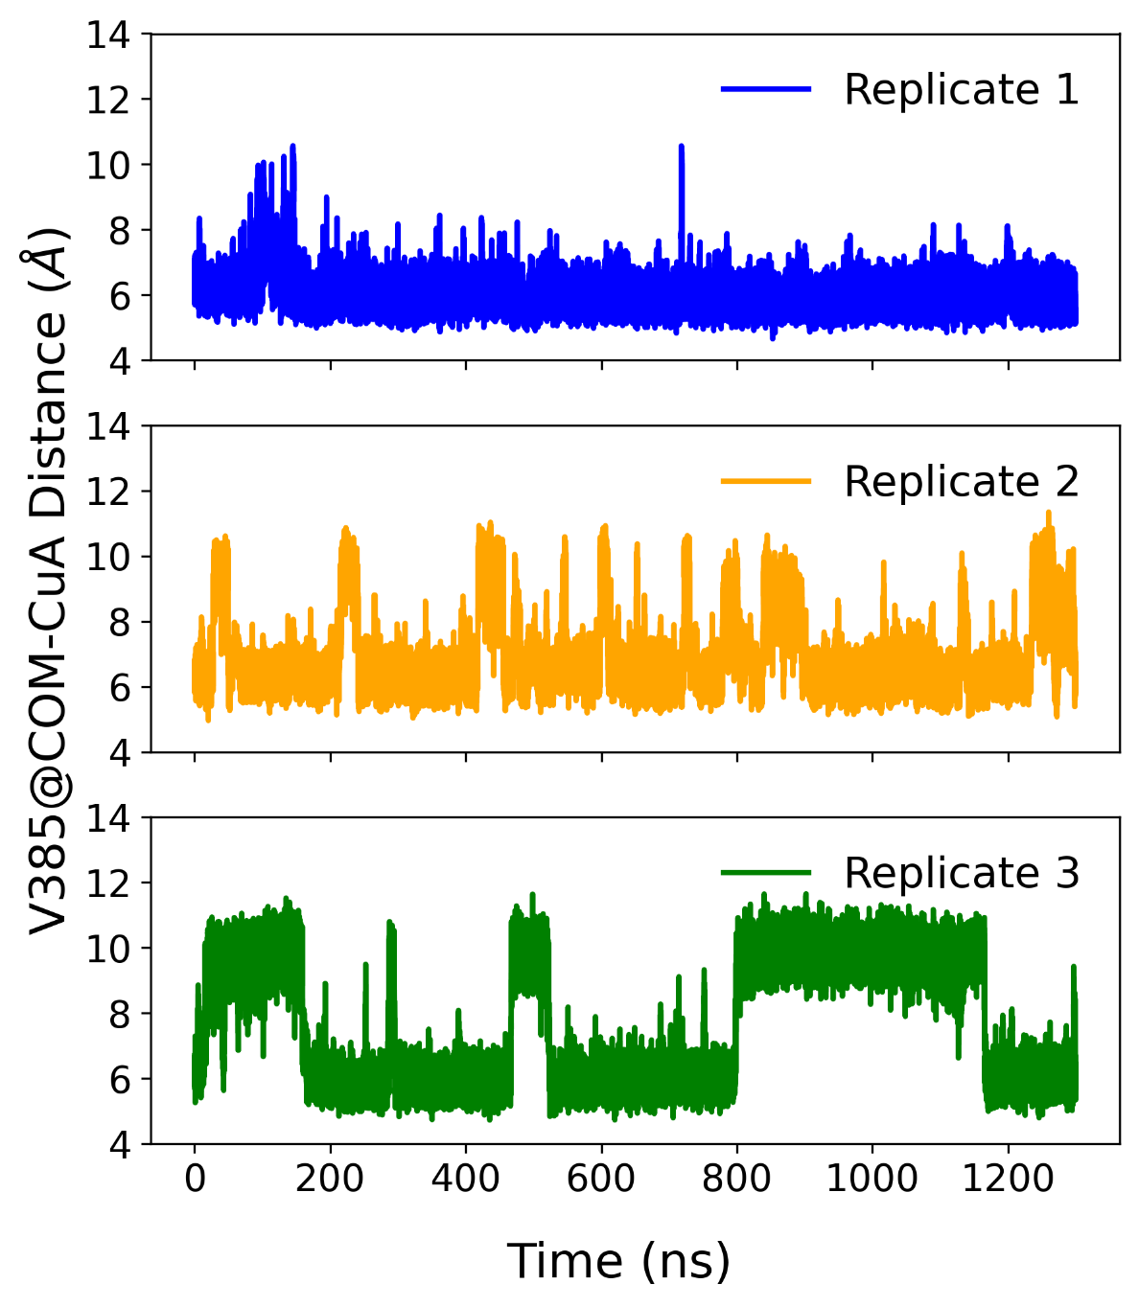
Figure S1. Time series for the distance (in Å) between center of mass for V385 to Copper A in the three replicates for the dark simulation. Here we see that replicate 1 mostly adopts the closed conformation for V385, as observed from its mostly uniform distances. However, we do see replicates 2 and 3 adopting the open conformation for quite some time, as observed from the consistent peaks over the course of the simulation.

White V385-CuA Distance:
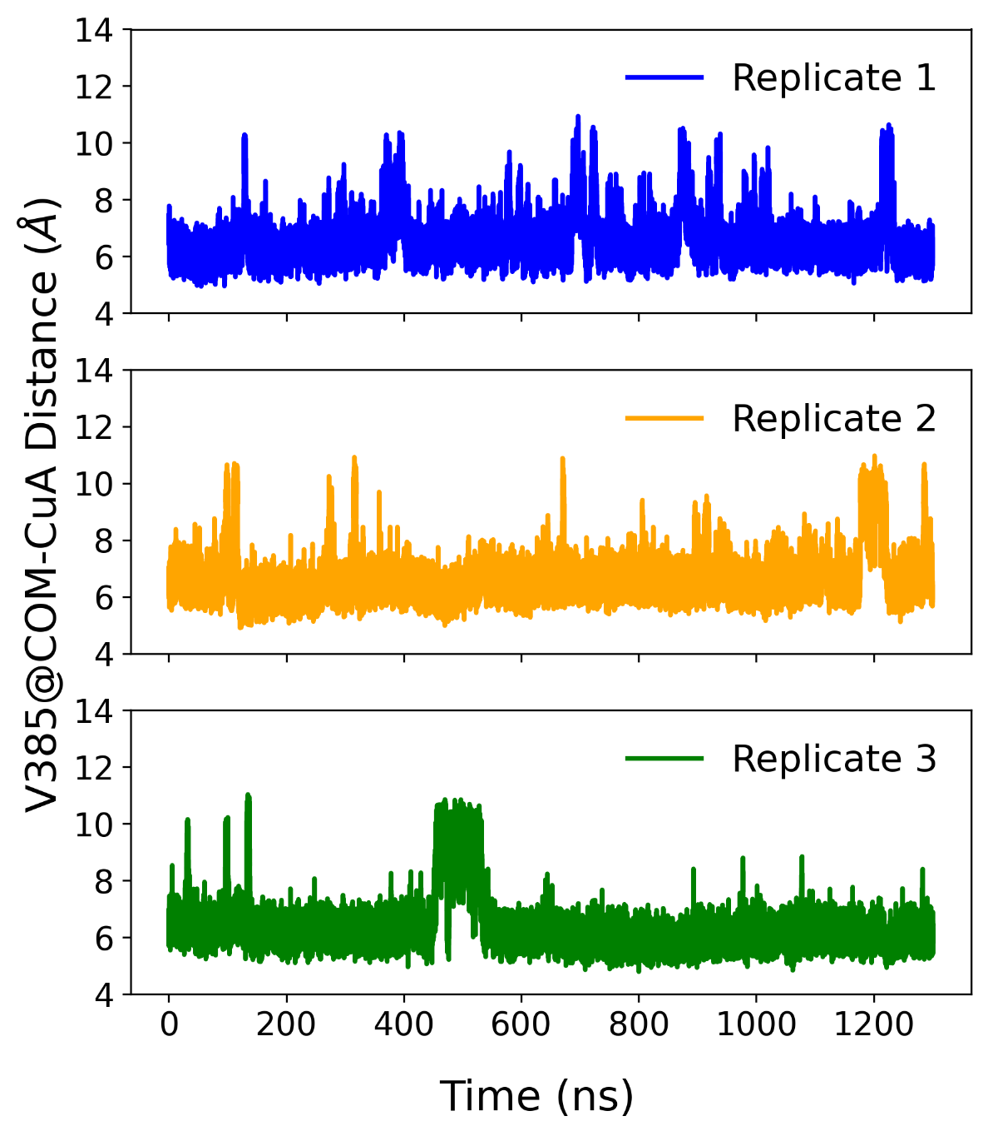
Figure S2. Time series for the distance between center of mass for V385 to Copper A in the three replicates for the white simulation. Here we see that for all three replicates, V385 mostly adopts a closed conformation, with scarce jumps to the open conformation during the simulation.

Dark Q386-H188 Distance:
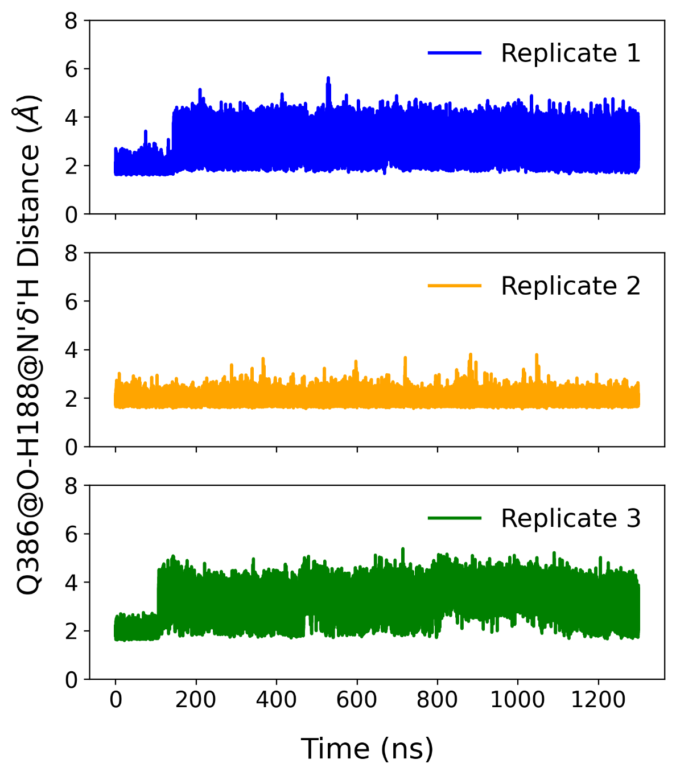
Figure S3. Time series for the distance between the hydrogen connected to Nδ of H188 to backbone O of Q386 in the three replicates of the dark simulation. Here, we observe that the hydrogen bond is relatively unstable in replicates 1 and 3, with the distance fluctuating between states corresponding to the presence and absence of the hydrogen bond. In contrast, replicate 2 exhibits predominantly stable hydrogen bonding.

White Q386-H188 Distance:
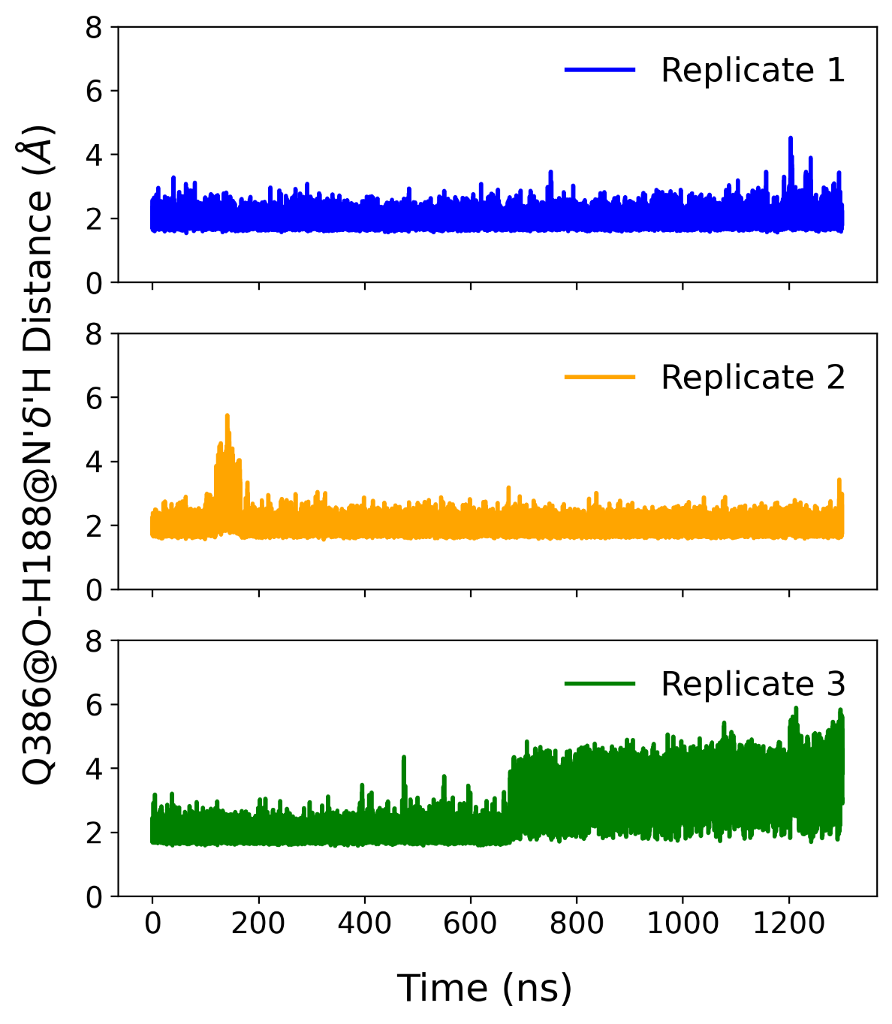
Figure S4. Time series for the distance between the hydrogen connected to Nδ of H188 to backbone O of Q386 in the three replicates of the white simulation. Here we see that for most of replicate 1 and 2 as well as for more than half replicate 3, the hydrogen bond is quite stable. For the latter half of replicate 2, the distance fluctuates between states corresponding to presence and absence of hydrogen bonding.

Differences in distances in replicates
For each system’s replicates, we do not see a lot of uniformity when it comes to these distances. The most uniform spread among the three replicates is for white system’s V385-CuA distance, where in all three replicates V385 adopted a closed conformation in upwards of 95% of the time. However, when we look at the dark system, we see that replicate 1 mostly adopts the closed conformation, whereas replicates 2 and 3 also adopt the open conformation, with replicate 3 having an almost uniform split between the two conformations it adopts.
As for the Q386-H188 hydrogen bond, we see that for the dark system, replicate 2 has an extremely stable hydrogen bond, whereas replicates 1 and 3 fluctuate between the two states. In contrast, in the white system, we see that replicates 1 and 2 have extremely stable hydrogen bonding, whereas replicate 3 fluctuates between the two states.
The lack of consistency across replicates for both the distances suggests that these coordinates sample from at least two distinct conformational space, whose interconversion occurs on a timescale that might be larger than each of the individual replicates. This indicates that the trajectories are effectively trapped in one state (such as dark replicate 1 and white replicate 1 and 2) or adopt the other state so scarce that they are not significant. Hence, it is best to look at their mean over the trajectory, rather than per frame error, as it might lead to misrepresentation of the data.

EXTRA AND PREVIOUS FIGURES
Q386-H188 Distance:
Dark:
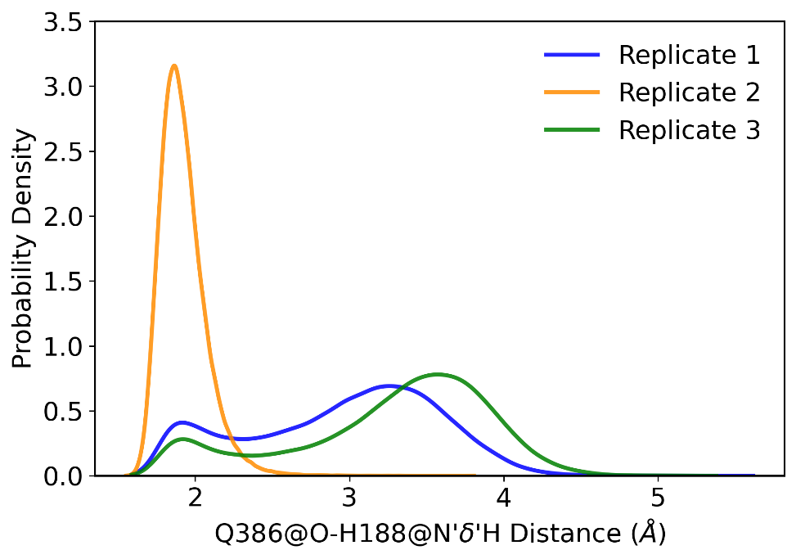
Figure 3. Probability density of the distance between the hydrogen connected to Nδ of H188 to backbone O of Q386 in the three replicates of the dark simulation
Average Q386-H188 White: 2.89 ± 0.91 Å
White:
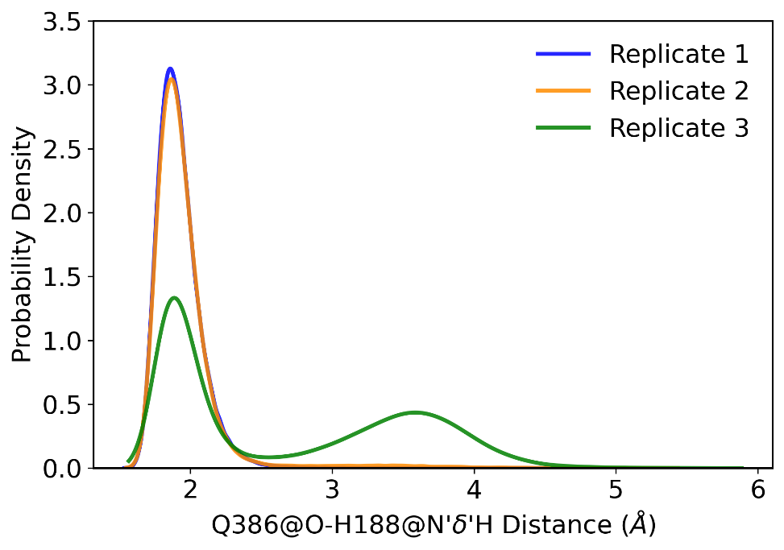
Figure 4. Probability density of the distance between the hydrogen connected to Nδ of H188 to backbone O of Q386 in the three replicates of the white simulation
Average Q386-H188 White: 1.87 ± 0.014 Å, 3.587 Å(small peak only rep 3)
V385-CuA Distance:
Dark:
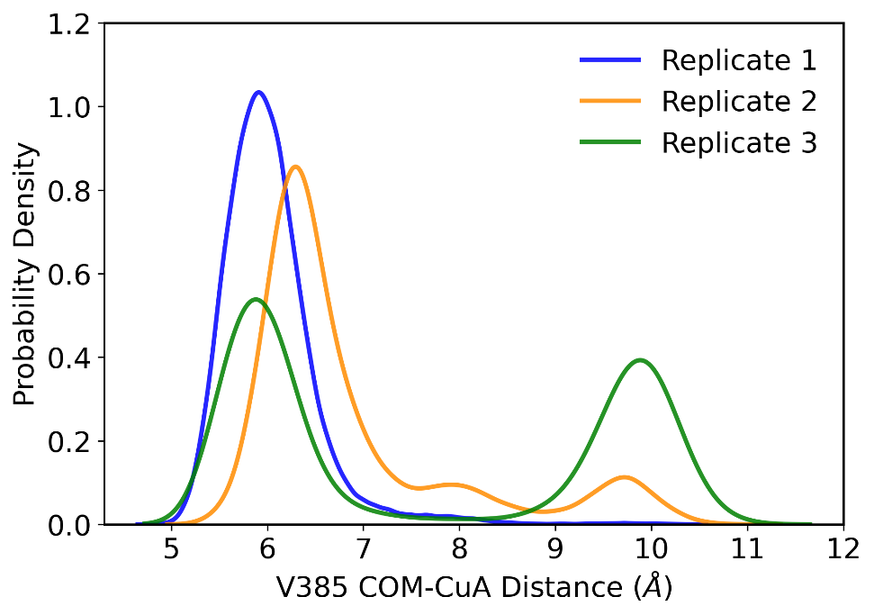
Figure 1. Probability density of the distance between the center of mass of V385 to Copper A in the three replicates of the dark simulation
Average V385-CuA Dark: 6.03 ± 0.23 Å, 9.88 Å (Reps 2 and 3 only)
White:
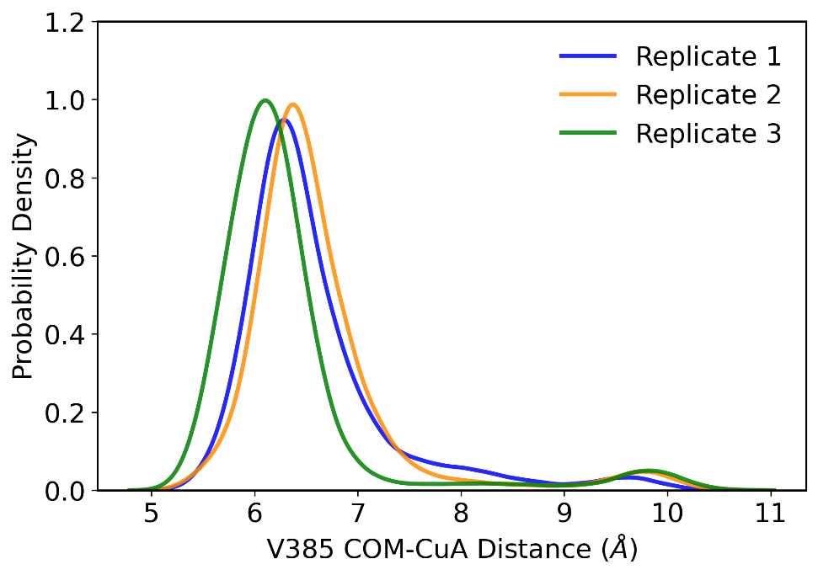
Figure 2. Probability density of the distance between the center of mass of V385 to Copper A in the three replicates of the white simulation
Average V385-CuA White: 6.25 ± 0.14 Å

Then calculate the average and std. Dev. peak values across the reps.
Average V385 COM-CuA White: 2.89 ± 0.91 Å
Average Q386-H188 White: 1.87 ± 0.014 Å, 3.587 Å(small peak only rep 3)
Average V385 COM-CuA Dark: 6.03 ± 0.23 Å, 9.88 Å (Reps 2 and 3 only)
Average Q386-H188 Dark: 6.25 ± 0.14 Å
Dark:
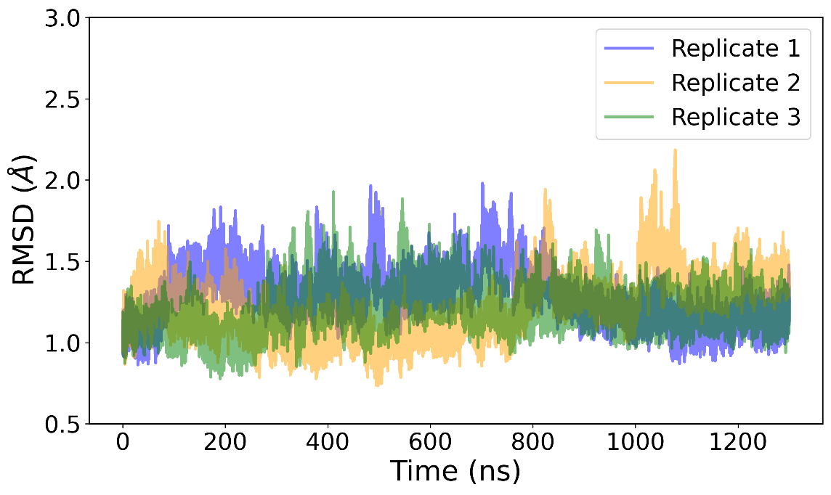
Figure 1. RMSD of Cα atoms of the protein residues for the three replicates of the dark simulation over 1300 ns of simulation per replicate.
White:
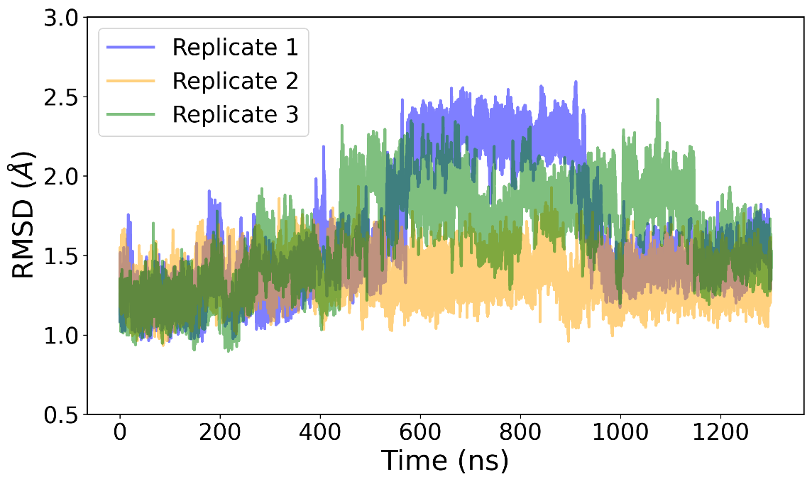
Figure 2. RMSD of Cα atoms of the protein residues for the three replicates of the white simulation over 1300 ns of simulation per replicate.
Dark:
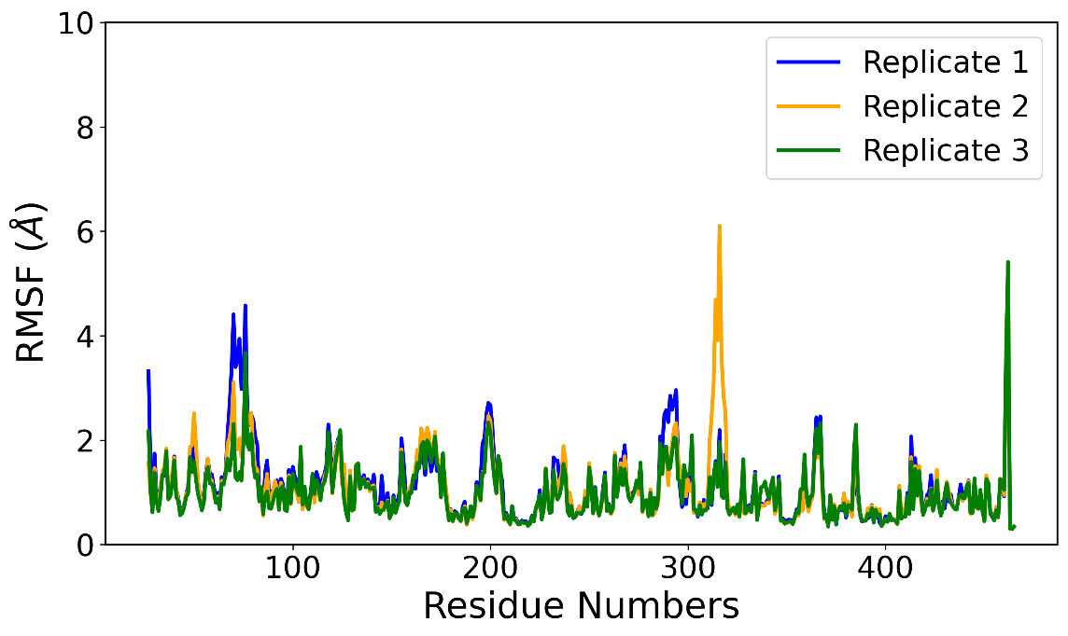
Figure 3. Per residue RMSF of heavy atoms for the three replicates of the dark simulation over 1300 ns of simulation per replicate.
White:
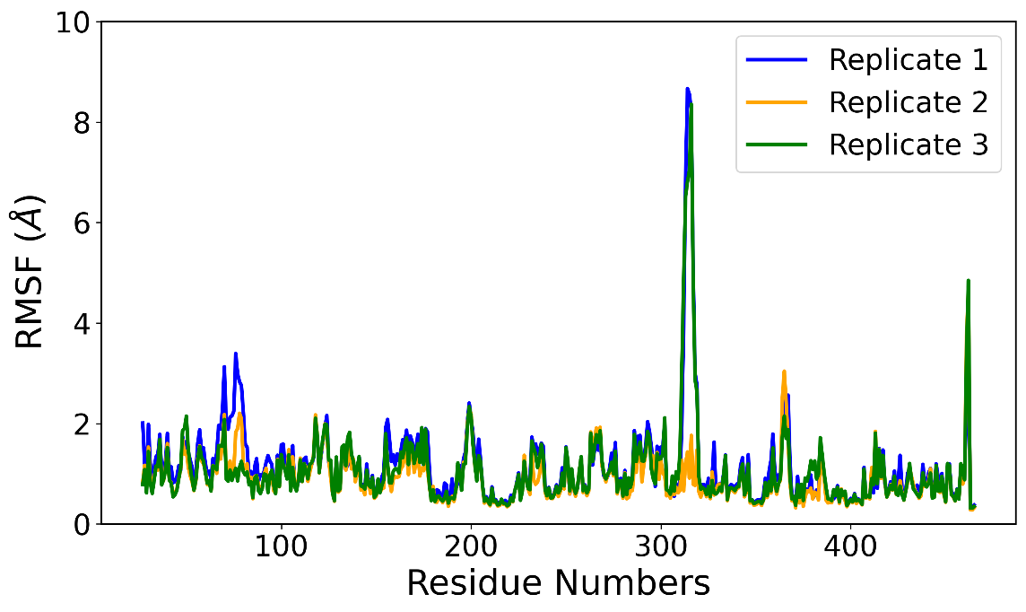
Figure 4. Per residue RMSF of heavy atoms for the three replicates of the dark simulation over 1300 ns of simulation per replicate.
Overall peak values for distances along with the probability density:
- White peak values for Q386-His H-bond distance:1.87Å (2.43), 3.59Å (0.15)
- Dark peak values for Q386-His H-bond distance:1.88Å (1.16), 3.43Å (0.46)
- White peak values for Val COM-CuA distance: 6.29 Å (0.96), 9.63 Å (0.033)
- Dark peak values for Val COM-CuA distance: 6.06 Å (0.70), 9.84Å (0.17)

